<https://www.nerdfitness.com/blog/2011/09/07/hiking/>

[*Already have a character? Click here to log in!*](https://www.nerdfitness.com/login)

# A Beginner’s Guide to Hiking

By [Steve](http://www.nerdfitness.com/)[110](https://www.nerdfitness.com/blog/2011/09/07/hiking/#comments)

[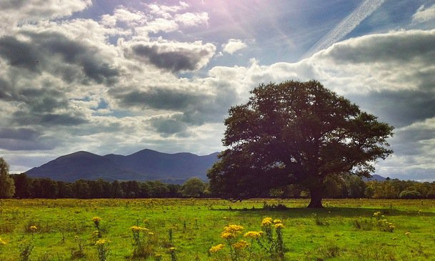](https://www.nerdfitness.com/blog/2011/09/07/hiking/)

**“It’s a dangerous business, Frodo, going out your door. You step onto the road, and if you don’t keep your feet, there’s no knowing where you might be swept off to.”**

I took the above picture while hiking through Killarney National Park in Ireland and couldn’t help but think back to my pals Frodo and Sam.  Doesn’t that look like that tree belongs in the Shire somewhere?  Seeing as you’re on Nerd Fitness, it can’t be any surprise to you that I’m a fan of The Lord of the Rings, as I’ve already used it to cover [lessons in productivity](http://nerdfitness.com/blog/2010/02/22/the-lord-of-the-rings-guide-to-getting-sh-done/" \o "Lessons in Productivity" \t "_blank) along with [life lessons learned from Tolkien himself](http://nerdfitness.com/blog/2011/04/28/tolkien-fitness/" \o "Tolkien" \t "_blank).

Welp, today I’m going to teach you how to hike with a little help from our furry-footed friends.  On top of that, I’m going to show you the nerdiest thing I’ve ever done – nobody will ever question my nerd cred again 🙂

## There and back again

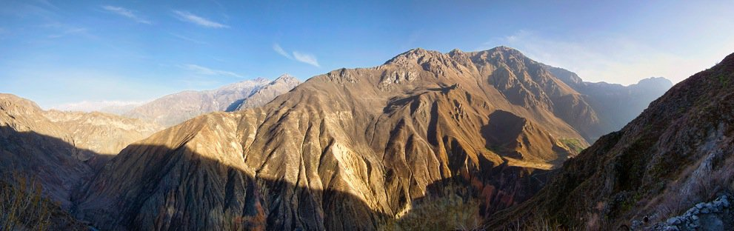

**When you think of hiking,** you probably imagine a bunch of road-tested perma-travelers with oversized backpacks hiking through epic mountains for weeks upon weeks at a time.  Or maybe, a pair of hobbits setting out on a worldwide adventure to destroy a ring of awe-inspiring power.

If you’re out of shape or just beginning your journey to a better lifestyle, thoughts about serious hiking can certainly keep you indoors and away from the trails.  However, although hiking can certainly be epic, it doesn’t need to be – it can also be a fun jaunt (who uses that word?) around your local park or neighborhood for a few hours on a Tuesday evening or Sunday morning.

**As long as you’re exploring your surroundings while building strength and endurance in your legs and lungs, I’m for it!**If you are overweight and not ready to [start running](http://nerdfitness.com/blog/2011/08/22/running-properly/" \o "Start Running" \t "_blank) yet, then hiking is a great way to get your legs, feet, and body used to strenuous activity – because you get to pick your speed and difficulty, you can always find a way the right amount of challenge for you.

**Here’s what you need to do:**

**1) Decide how long you have to hike.**  As this is a beginner’s guide to hiking, we’re not looking to hike the Appalachian Trail – but rather trails that can be done in less than a day, that won’t require you to pack a tent, or bring extra change of clothes.  Pick a hike based on how much time you have – do you have the entire Sunday?  Or do you just have a few hours on a Tuesday afternoon?

**2) Decide if you’ll be hiking solo or with a friend/group** – I love hiking solo – it’s mobile meditation for me.  However, it’s also more dangerous should anything happen while you’re out on the trail; so if you’re a little more cautious, then I’d recommend buddying up with a friend or your significant other for your hike.  It’s the perfect bonding opportunity.

**3) Determine your starting level** – if you are a complete newb and horribly out of shape, sending yourself out on an eight hour hike through the unmapped wilderness is incredibly unintelligent.  Start slow, and pick places around your town that will allow you to stop when necessary and get back to your car or home quickly.  No need to be a hero; it’s always better to come back excited and say “wow that was easier than I expected!” than to realize you’re six hours from home and out of steam.

**4) Pick your hiking location** – Go to [Trails.com](http://www.trails.com/" \o "trails.com" \t "_blank), put in your zip code, find your hiking trail!  Or drive around your town until you find a park that looks like fun.  Ask your friends or coworkers if they know any good spots.  Go to a local golf course and go hiking through the woods (collecting all the Titleist Pro-V1 balls you find and sending them to me).  Type in “[your town name] + hiking” on Google and see what pops up.  The world is FULL of hiking trails and awesomeness – you just need to know where to look.

**5) Let somebody else know** – if you are out hiking alone, take the time to email or call somebody and let him know that you’ll be hiking and when you expect to be back.  We don’t want to hear about any [127 Hours](http://en.wikipedia.org/wiki/127_Hours" \o "127 hours" \t "_blank) stories on NF…that would make playing videogames way more difficult.  You don’t need to tell them the brand of your underwear (please tell me you’re wearing underwear) or how many almonds you’re bringing, but let them know the important details so if they don’t hear back from you by a certain time they know to alert the proper authorities.

## What to wear

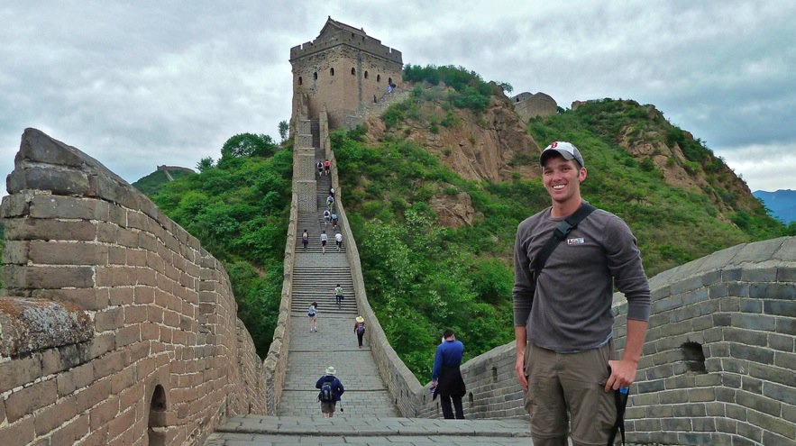

**Stilettos, your favorite mini skirt, and a fishnet halter top.**You’re welcome!

In all seriousness, I’m a big fan of being comfortable without breaking the bank.

**Let’s start with footwear:** You have a few options:

* **Big clunky hiking boots** – personally, I hate these things.  They cause the same issues with your feet that running in super cushiony shoes do – they give too much support and promote an improper foot strike while walking.  On top of that, they are damn heavy.  In my personal opinion, I like to attack hiking differently; however, if you swear by hiking boots and have a $200 pair of Timberlands, I’m not gonna tell you to chuck them.
* **Sneakers** – I’d probably choose boots over regular sneakers when it comes to hiking, as at least the boots are designed specifically for hiking.  However, if sneakers are your only option, lace em up and start your hike.  Just be careful on slipper surfaces as often sneakers won’t give you the grip you need to get over them.  You can also try barefoot trail running shoes like the [Merrell Trail Gloves](http://www.amazon.com/gp/product/B004IHNHQK/ref=as_li_ss_tl?ie=UTF8&tag=nerdfitn-20&linkCode=as2&camp=217145&creative=399373&creativeASIN=B004IHNHQK" \o "merrell trail gloves" \t "_blank).  Just make sure your feet are prepared for less support.
* **[Vibram FiveFingers](http://www.amazon.com/gp/product/B004R9WLYI/ref=as_li_ss_tl?ie=UTF8&tag=nerdfitn-20&linkCode=as2&camp=217145&creative=399373&creativeASIN=B004R9WLYI" \o "Vibram FiveFingers" \t "_blank) –** My vibrams have become my go-to for a shoe while hiking.  Something just feels right about gripping the rocks under my feet while hiking up and down mountain paths.  Now, before you strap on a pair yourself and go for a four-day hike…I’ve been wearing Vibrams for two and a half years or so – my ankles and feet and joints have been prepared for strenuous activity.  If you are going to go the “barefoot” route, start slow, start small, and gradually build up distance and difficulty.  Be comfortable, but be safe.

**Socks** –  disclaimer: I’m usually hiking in my Vibrams without socks so I won’t claim to be an expert on hiking socks.  If you’re wearing boots or sneakers, you want to wear socks that aren’t going to give you blisters or make your feet all sweaty and gross.  Depending on how long the hike is, how serious you are about hiking, and your budget, you can look into super fancy [merino-wool socks](http://www.amazon.com/gp/product/B000TFDJVI/ref=as_li_ss_tl?ie=UTF8&tag=nerdfitn-20&linkCode=as2&camp=217145&creative=399373&creativeASIN=B000TFDJVI" \o "merino wool" \t "_blank).  The main issue I found with hiking great distances (before switching to vibrams) was blisters and discomfort in my feet from crappy socks on all-day (7+ hour) hikes.  If you have sock advice, make sure to leave it in the comments.

**Pants –** Don’t go pantsless through the wilderness – best tip I can give you all day.  No, the real advice when it comes to pants/shorts is heavily dependent upon your environment.  If it’s going to be cold, shorts might keep you shivering.  If it’s going to be hot, pants might get too uncomfortable.  Only wear jeans if its going to be a comfortable temperature and/or you have no other option – being sweaty and hot while wearing jeans sucks.  I’m a big fan of my nerd pants – the [Columbia Silver Ridge pants](http://www.amazon.com/gp/product/B003VWC4H6?ie=UTF8&tag=nerdfitn-20&linkCode=as2&camp=1789&creative=390957&creativeASIN=B003VWC4H6" \o "columbia" \t "_blank).  Although they look kind of goofy, they’re incredibly light weight, dry quickly, and can [transform](http://nerdfitness.com/blog/2010/04/24/make-optimus-prime-proud-learn-how-to-transform-your-life/" \o "Transform pants" \t "_blank) from pants to shorts in mere seconds!

**When in doubt (or if you are traveling through woods), wear pants.** I am horribly allergic to poison ivy, so I like to keep as much of my body covered while hiking to make sure I don’t get it.  True story: when I was a little kid, I made myself a little bow and arrow (trying to be like [Link](http://nerdfitness.com/blog/2010/07/29/what-we-can-learn-from-the-greatest-video-game-of-all-time/" \o "link" \t "_blank)) and unknowingly feathered my homemade arrows with poison ivy leaves.  When my hands and half of my face swelled up like a balloon from drawing the arrows back across my cheek, I learned my lesson 🙂

**Shirt** – Intense hike? Wear a performance based shirt like Under Armour or something similar to keep you unsweaty and comfortable.  Although it does have some cotton in it, the [Nerd Fitness t-shirt](http://nerdfitness.wazala.com/" \o "NerdFitness tshirt" \t "_blank) (shameless plug) does hold up quite well to wear and tear over long periods of time – I’ve been rocking my shirt in heavy rotation on lots of hikes over the past 10 months in absolute comfort.  You can also wear things like [merino wool long shirts](http://rcm.amazon.com/e/cm?lt1=_blank&bc1=000000&IS2=1&bg1=FFFFFF&fc1=000000&lc1=0000FF&t=nerdfitn-20&o=1&p=8&l=as4&m=amazon&f=ifr&ref=ss_til&asins=B0006FK2QG" \o "merino wool" \t "_blank) and [t-shirts](http://www.amazon.com/gp/product/B002GP7WUS/ref=as_li_ss_tl?ie=UTF8&tag=nerdfitn-20&linkCode=as2&camp=217145&creative=399373&creativeASIN=B002GP7WUS" \o "merino wool" \t "_blank) which are very light, wick away moisture, hide odors, and breathe well – though you will be paying top dollar for them.  If you’re just starting out, pick an old t-shirt and rock that – you can work on optimizing performance once you’ve got a few hikes under your belt.

**Jacket** – I’ve been wearing this [Mountain Hardware jacket](http://www.amazon.com/gp/product/B002N7ANO6?ie=UTF8&tag=nerdfitn-20&linkCode=as2&camp=1789&creative=390957&creativeASIN=B002N7ANO6" \o "Mountain Hardware Jacket" \t "_blank) on most of my hikes and it has been awesome – very lightweight so packing it isn’t a hassle, almost 100% waterproof so it keeps me dry when it rains, and heavy enough to block the wind to keep me warm when it’s chilly.  Don’t go out of your way to buy a new jacket if you have a decent wind breaker, but if you’re going to be doing a lot of hiking or you’re in the market for a new coat, here’s my advice: go to a local store and try out all of the jackets until you find one you like.  Once you find the perfect jacket, go home and check online (you can sometimes find the same jacket for up to 60% less) – then, ask the local store if they’ll price match or just buy it online.

**Hat –** I’m usually rocking my Red Sox hat (booo Yankees), but while [hiking in Australia](http://nerdfitness.com/blog/2011/04/19/try-it/" \o "hiking through australia" \t "_blank) I wore a hat with a giant floppy brim to keep my ears and face protected from the sun.  The tops of your ears and back of your neck are highly susceptible to getting burned while on the trail, so either get some sunscreen or wear a hat that keeps them covered.

**Moral of the story – versatility for the win.** If your weather forecast is “75 and sunny,” you can severely limit what you’re bringing with you.  If it’s questionable or looks like things might change during the day, versatility is your best bet – a jacket, pants that can become shorts, a long sleeve shirt that you can take off or roll the sleeves up, etc.  Don’t go out and buy all new stuff until you’re sure hiking is an activity you want to invest in.  Borrow from friends, make do with what you have – just get started.

## What to pack

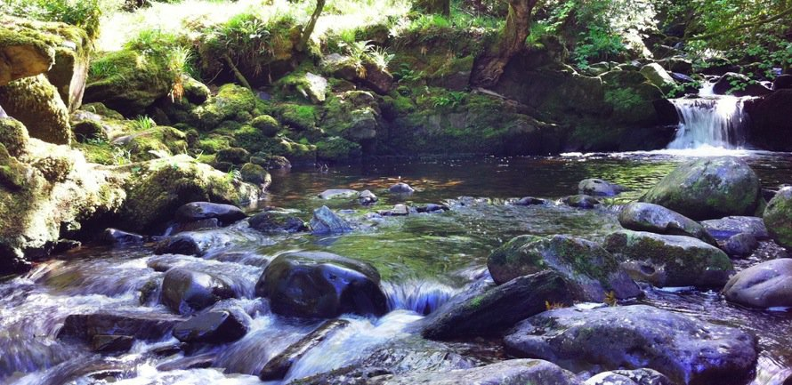

**Now, a lot of this will depend on how long your planned hike is and what sort of weather/obstacles/adventures you’re bound to get yourself into on the hike.**  If you’re just getting started, I’m going to guess you won’t be [hiking across America](http://www.natewalksamerica.com/" \o "hiking across the USA" \t "_blank)or scaling mountains, but rather going on an introductory hike that will help build your confidence and get you rolling.

Here’s what I’d recommend you bring with you on your adventure:

**Some sort of small backpack.**  You won’t be traveling with too much stuff, so you don’t need to go out and buy a $300 75L ultra backpack.  Any bag that will hold your stuff is sufficient for now – if you decide down the road to get super serious about this camping stuff, you can invest money.  Until then though, use what you have or borrow your little sister’s Dora the Explorer pack.  Wait, don’t do that.

**Make sure your cellphone is fully charged and ready to go** – a phone can help bail you out in case of emergency, and if you have a smart phone it can multitask as your compass, distance tracker, mapper, and so on.  If you don’t have a smart phone, bringing a compass or GPS system isn’t a bad idea (unless it’s bright and sunny and you’re good at orienting yourself).  If you’re a audiophile and need music playing 24/7 like I do, you’ll also need headphones so you can listen to your epic soundtrack (explained later).

**A camera –**  Throw a camera in your bag, you never know what you’ll find.  Although I have a camera that I travel with, most of the pictures I’ve been taking recently have been done with my iPhone using apps like [Camera+](http://campl.us/" \o "Camera Plus" \t "_blank) or [ProHDR](http://itunes.apple.com/us/app/pro-hdr/id347104281?mt=8" \o "Pro HDR" \t "_blank) (which I freaking love).  Both apps are worth the price.  You don’t need to be a great photographer, just need to capture the moment to look back on fondly as a crotchety old grandpa.  Obviously if you’re a serious photographer, you’ve already planned to pack your DSLR so I won’t get into that.

**A book –**I LOVE READING (more than I love lowercase letters), so I always travel with my [Kindle](http://www.amazon.com/gp/product/B002FQJT3Q/ref=as_li_ss_tl?ie=UTF8&tag=nerdfitn-20&linkCode=as2&camp=217145&creative=399373&creativeASIN=B002FQJT3Q" \o "Kindle" \t "_blank) on a hike.  Although hiking with friends can be fun, I get a huge thrill out of hiking out to a remote location overlooking a valley or sitting on the edge of a river with a book so that I can spend a few hours getting lost in a story (just finished reading [A Dance With Dragons](http://www.amazon.com/gp/product/B003YL4LYI/ref=as_li_ss_tl?ie=UTF8&tag=nerdfitn-20&linkCode=as2&camp=217145&creative=399373&creativeASIN=B003YL4LYI" \o "Dance with Dragons" \t "_blank), now moving on to [A Wise Man’s Fear](http://www.amazon.com/gp/product/B00475AYJQ/ref=as_li_ss_tl?ie=UTF8&tag=nerdfitn-20&linkCode=as2&camp=217145&creative=399373&creativeASIN=B00475AYJQ" \o "Wise Man's Fear" \t "_blank).)

**Sunscreen –**If it’s sunny outside and you’re hiking through the woods or up a mountain with a cool breeze in your face, you probably won’t be able to tell that your ears and face are getting absolutely torched.  Get yourself some 30SPF waterproof sweatproof sunscreen to cover up those ears, cheeks, and back of your neck.

**Bug spray –** especially if it’s “that time of the year” in your area where bugs are out in full force.  Nothing worse than coming home to arms and legs covered in bug bites.

**First aid** – Having some first aid stuff with you is a good idea: band-aids and moleskin for blisters and cuts, Neosporin or some type of disinfectant for cuts/scrapes, and maybe a bandage or two just in case.  Places like REI sell travel first aid kits if you’re too lazy to make your own.

**Pocket knife** – Not essential if you’re in a park, but a good thing to have with you out in the woods so you’re prepared for anything. [Like McGyver](http://nerdfitness.com/blog/2011/02/10/macguyver/" \o "MacGyver" \t "_blank).

**Sunglasses –** No need to go blind while out on the trail.  You probably already have sunglasses floating around your house: I’d recommend bringing the $5 ones rather than the $250 Ray-Bans.

**FOOD!**  How much you need to bring will depend greatly on your type of trip, but you want to make sure you are adequately prepared for your adventure.  Although we don’t have [lembas bread](http://en.wikipedia.org/wiki/List_of_Middle-earth_food_and_drink" \l "Lembas" \o "lembas bread" \t "_blank) to keep our stomachs full for days, we do have some high quality foods that will keep us energized and healthy.

**Although by no means a complete list of snacks, this is usually what I like to pack in my bag before a hike:**

**Nuts** – Almonds or walnuts.  Great for snacking on, loaded w/ healthy fat and protein.  They are high in calorie content however, so if you are trying to lose weight, don’t do a 10 minute walk and eat 4000 calories worth of nuts.  We in the business like to call that “counterproductive.”

**Water** – sorry Ditka, this is the lifeblood that [drives the dreams of champions](http://www.youtube.com/watch?v=6PH9uCs0als" \o "drives the dreams of champions" \t "_blank).  Do not leave home without a water bottle.  I’m partial to stainless steel/ aluminum water bottles over Nalgene or reused plastic bottles, but that’s another lesson for another day.  Make sure you bring enough water with you to keep you hydrated through your adventure – a liter or two should be sufficient.  Not only that, but make sure you have been consuming water before you go hiking so that you’re not starting at a hydration deficit.

**Fruit** – I throw two or three apples in my bag; apples and nuts mean I’ve pretty much got all of the fat, protein, and carbs I need for my day.  Things like bananas, raisins, and other fruit are good options as well – pick based on your personal preference and tastes.

**Bread and almond butter** – I know it’s not [paleo](http://nerdfitness.com/blog/2010/10/04/the-beginners-guide-to-the-paleo-diet/" \o "paleo" \t "_blank), but if you’re going to be gone all day and you’re a bread eater – toss a loaf of wheat or flaxseed bread, a butter knife, and a jar of almond butter or peanut butter in your bag – doesn’t get much simpler than that.  If you’re not a bread eater, cut up your apples and dip the slices into the almond butter – best snack ever.

**Beef jerky!** [Make your own](http://www.marksdailyapple.com/how-to-make-your-own-jerky/" \o "make your own jerky" \t "_blank) or go with some high quality store bought stuff.  Lots of protein, easy to pack, and keeps well.  Mmmmmm.

**What about trail mix or granola bars?**  You’d probably think granola bars and trail mix are synonymous with hiking, but I’m actually not a fan of either unless they’re homemade – these products are usually loaded with salt/sugar and processed grains and are pretty damn unhealthy.  If you’re gonna go with trail mix, make your own with dried fruit and raw unsalted nuts.  If you DON’T have other options, tossing a few granola bars in the bag isn’t the end of the world.

**More food advice here: [Primal Trail Food](http://www.marksdailyapple.com/primal-trail-food/" \o "primal trail food" \t "_blank)**

## Tips and Tricks

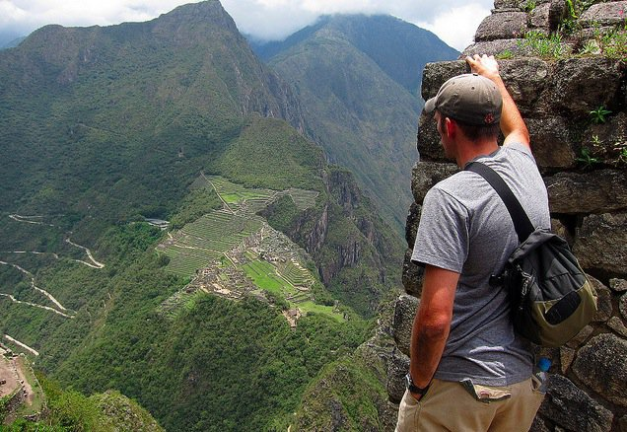

**Aim for the high ground** – I love hiking to tall things: the top of a mountain, the high point in a town, the roof of a building.  It gives you a great halfway point to stop, eat some lunch or dinner, and enjoy the view; plus, you already know exactly how far you need to go on your way down.  One piece of advice on going DOWN a steep mountain or a lot of steps.  Shorten your stride, and take care to land on the balls of your feet with a bent knee if possible – if you’re landing on your heels for thousands of steps, it can wreak havoc on your knees and joints as there’s no shock absorption.  I remember how sore my knees were the day after hiking down [Colca Canyon in Peru with my buddy Cash](http://www.nerdfitness.com/wp-content/uploads/2010/11/Screen-shot-2010-11-18-at-2.21.33-PM.png" \o "colca canyon" \t "_blank) because I didn’t make an effort to soften my steps and take care of my body.

**Urban Hiking –**“But Steve I live in a city, I can’t go hiking!”  OH REALLY FOOL!? Why the hell not?  Load up your backpack, map out a route on Google maps, maybe even find a tall building – avoid the elevator, climb the steps.  Or walk until you find a park, sit on a bench and read a book.  Sure, it’s not the same as hiking the Rockies, but it will still get your heart pumping and feet moving!

**Keep track of it –** If you have an iPhone or Android phone, download a hiking or running app to keep track of how far you go and how much hiking you do.  Although I haven’t been tracking my hikes abroad (I leave my phone in Airplane mode while traveling), I’ve heard great things about [RunKeeper](http://runkeeper.com/" \o "runkeeper" \t "_blank) and [EasyTrails](http://easytrailsgps.com/" \o "easytrails" \t "_blank).  If you have more apps or suggestions on how to keep track of your hikes, let me know in the comments and I’ll add them here.

**Make a hiking soundtrack –** Now, you might be interested in listening to the sounds of nature while you hike – more power to ya!  Also, for safety reasons, it might not be advisable to listen to music while hiking (I will leave that decision up to you).  However, if you hare in a safe part of the country, you know the area, and you feel comfortable putting on music, make an epic hiking soundtrack.  I recommend picking tunes from the Lord of the Rings soundtrack (duh) or from your workout playlist to push you up the difficult parts.  I have not found the music of Barbara Streisand to be a great motivator.

**Geocaching –**Although I’ve never done it, I’ve heard great fun can be had while[geocaching](http://www.geocaching.com/" \o "geocaching" \t "_blank).  Simply go to the website, track your location, and then decide on which cache you’re going to track down.  Think of it like a real life version ofIndiana Jonesor Uncharted, minus the Nazis and undead warriors.

**Clean up/check for ticks –**if you’re in a heavily wooded area and carving through the wilderness, check yourself for ticks and make sure you take a shower with hot water and soap immediately when you get home in case you came in contact with any poisonous plants or things like that.

**Give a hoot, don’t pollute –**Pack it in, pack it out.  If you bring anything with you, it better be coming back with you.  Don’t leave trash in the woods, and pick up any extra trash you see out there.  The wilderness thanks you for your service, citizen!

## More resources



**This article is just a primer, meant to whet your appetite and make you excited to go hiking and exploring the wonderful world around us.** Here are a few other resources on hiking if you want more information.  Feel free to let me know about more in the comments:

* [Tips for Primal/Paleo Hiking](http://www.marksdailyapple.com/forum/thread9990.html" \o "primal hiking" \t "_blank)
* [Hiking Emergencies on Art of Manliness](http://artofmanliness.com/2010/09/29/underestimating-a-hike/" \o "Art of Manliness Hiking" \t "_blank)
* [American Hiking Society](http://www.americanhiking.org/" \o "American Hiking Society" \t "_blank)

## Steve Goes Full Nerd

**Remember how I said that epic tree reminded me of Lord of the Rings and the Shire?**Well, just one week prior I had purchased a tin whistle while in Galway, and the only thing I I wanted to learn how to play was “Concerning Hobbits.”  While hiking on that particular day, I had put the whistle in the bag just in case I got to a place where there was NOBODY around so that I could practice.  Sure enough, I found “the Shire” and empty fields for hundreds of yards in every direction, so I figured “why not?!”

[Steve Goes Full Nerd Video](http://www.youtube.com/watch?v=x_dHh0v3rJY" \o "Steve Goes Full Nerd" \t "_blank)

**Now, I don’t think Howard Shore or Peter Jackson will be contacting me for work on “the Hobbit” any time soon, but it’s not bad for a week, eh?**

## Not all those who wander are lost